Wolston, Brandon & Bretford Joint Burial Committee
Councillors are hereby summoned
to attend a meeting of the WBB-JBC to be held
6.30 pm on Thursday, 22nd January 2026
at Wolston Baptist Church, Main Street Wolston, CV8 3HJ
A Public Forum for members of the public and press will begin at 6.30 pm to raise any matters of concern with the Joint Burial Committee. A time limit of 5 minutes to speak, per person, may be imposed at the Chair’s discretion, in order to keep to schedule. The Chair will close the forum no later than 7.00pm and the formal meeting will commence.

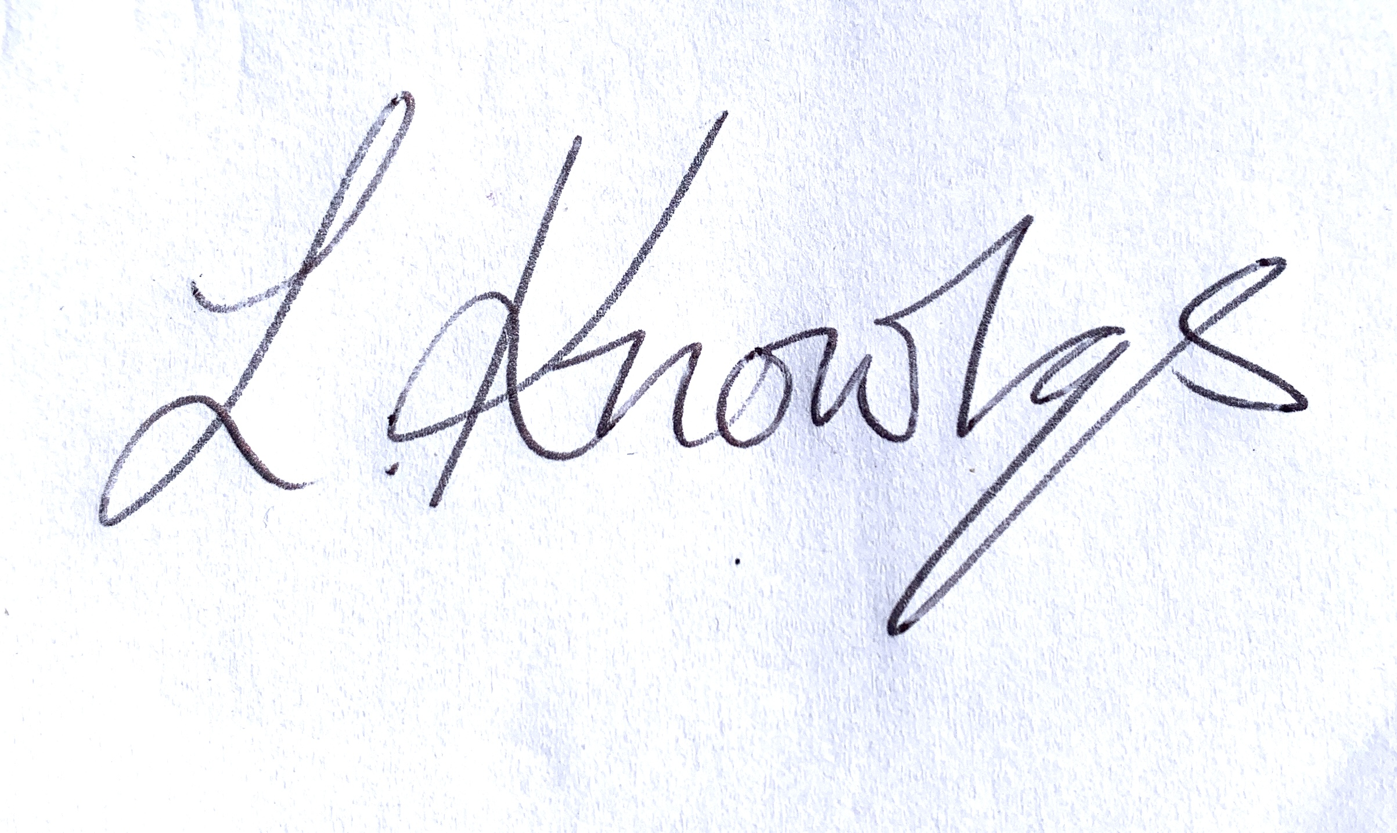

Lorraine Knowles Clerk & RFO email: wbbjbc@wolstonpc.co.uk

JBC Item no. | DRAFT MINUTES | Lead
83. | Welcome: - JBC Cllrs,  - Members of the Public  Apologies | Chair
84. | Declarations of Interest (existence and nature) on items on the agenda: Councillors to declare any personal and/or pecuniary interests on items on the agenda. | Chair
85. | Minutes of previous Meeting: Review and approve, if appropriate, minutes of the Joint Burial Committee meeting held on 27th November 2025. | Clerk
86. | Matters arising from the minutes/actions list (unless included below)  - Cemetery Post Box update  - £10 donation December 2019 update | ALL
87. | Correspondence: to note items of correspondence received or sent since last meeting (for information only)  - Enquiry re. reserved ashes plot | Clerk
88. | Finance Report:  To endorse (and approve, if appropriate) accounts for period  13.11.25 – 12.1.26  - Payments made  - Payments received  - To note bank reconciliation. | Clerk
89. | Banking  - Retention of existing current bank account with HSBC  - Movement of savings account to higher interest account | Clerk
90. | Budget  - Summary of annual costs for running of cemetery  - Forecast of land use in cemetery | Clerk
91. | Terms of Reference  To discuss and make decision on structure and review of Terms of Refence for WBBJBC | ALL
92. | - Purchase of Exclusive Rights of Burial  none  - Prepurchase of Exclusive Right of Burial  none  - Interments of ashes:  none | INFO
94. | Memorials:  Application for Permits for memorials  None | INFO
94. | Cemetery Maintenance and Grass Cutting Review:  - Quote for cemetery maintenance costs for 2026 – 27.  - Improvement of track in cemetery for vehicle access | Clerk
95. | AOB & Future Agenda Items: Cllrs. to advise Clerk at least 10 working days prior to next meeting.
96. | Date and Venue for next meeting – 6:30p.m.Thursday 26th March 2026 at Wolston Baptist Church. | ALL
97. | Exclusion of Public and Press  In accordance with Para 1 (2) of the Public Bodies (Admission to Meetings) Act 1960, the WBBJBC resolves that the press and public be excluded from the meeting during consideration of other Agenda items due to the confidential nature of the business transacted, where the public interest would not be served in disclosing this information. Further, the exclusion is on the grounds that items of business to be discussed are likely to include matters that are personal and confidential and therefore exempt from public disclosure. | ALL
98. | Committee Personnel Matter  - Update on meeting with resident regarding pre-purchase of ERoB for ashes plot for relatives who are not residents.  - Update on response to correspondence expressing difficult position of JBC with lack of documentation for cash payment of deposit. | ALL
Close of Meeting:

